Model Aeronautics
Association of Canada
Unit 9, 5100 South Service Road
Burlington, ON L7L 6A
Attn: Linda Patrick
Hi Linda,
The F2B Team Trials were conducted on Sunday September 11th at Crowland Park in Niagara Falls Ontario. Crowland Park features an extremely nice paved control line circle located in area free of trees and buildings that cause turbulence.
The Team Trials were conducted by CD John McFayden 14681L and judging was done by three experienced F2B competitors namely Dave Kelly 3070, Len Bourel 14801 and John McFayden 14681L. Tabulator was Naomi Macklem 82384.
There were 3 entrants in the Team Trials, Konstantin Bajaikine 61045, Kim Doherty 32008 and Peter Hanson 65002.
Each competitor completed 3 official flights. The weather conditions were ideal with light overcast and gentle wind.
The results were as follows:
Pilot | Flight 1 | Flight 2 | Flight 3
Konstantin Bajaikine | 145.42 | 146.47 | 150.03 | 1 st
Kim Doherty | 144.13 | 142.8 | 145.27 | 2 nd
Peter Hanson | 140.77 | 140.93 | 138.73 | 3 rd

Enclosed is a cheque for $75 for the FAI Travel Fund collected at this event.
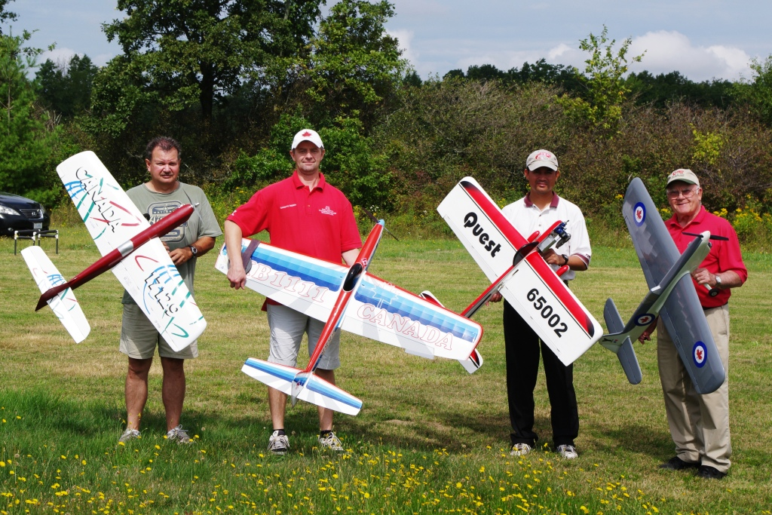
Respectfully submitted,

John McFayden 14681L
Committee Chair
Control Line Precision Aerobatics

